**Evaluating NBA Player’s Height and Weight**

Nirav Naidu

**Introduction**

The data set that was utilized is “all_seasons_nba”, a data set from Kaggle. This data set allows you to see various stats from player name, height, team, weight, draft year, draft round, games played, etc. The variables that are being assessed are height and weight. Knowing a player's height, our training specialists can help individual players achieve their desired weight based on their height. 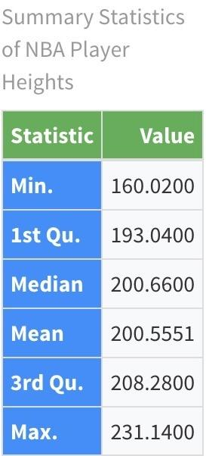

Using the table to the left, we can see the summary statistics for player heights in centimeters (cm). We can see that the mean is 200.5. That means that the average height for NBA players that were included in this data set was 200.5 (cm). **Below is the accompanying histogram for player height.**

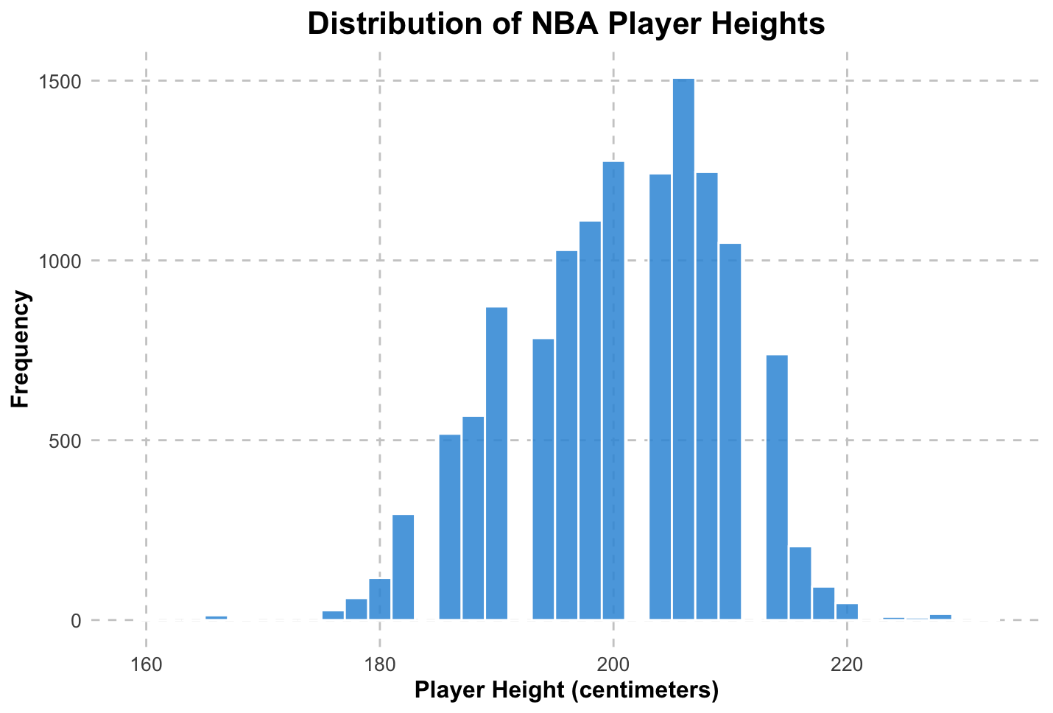

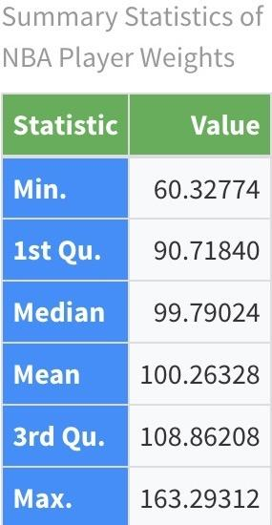

Using the table to the right, we can see the summary statistics for player weights in kilograms (kg). We can see that the mean is 100. This means that the average weight in pounds for NBA players is 100.3 kg. **Below is the accompanying histogram for player weight.**

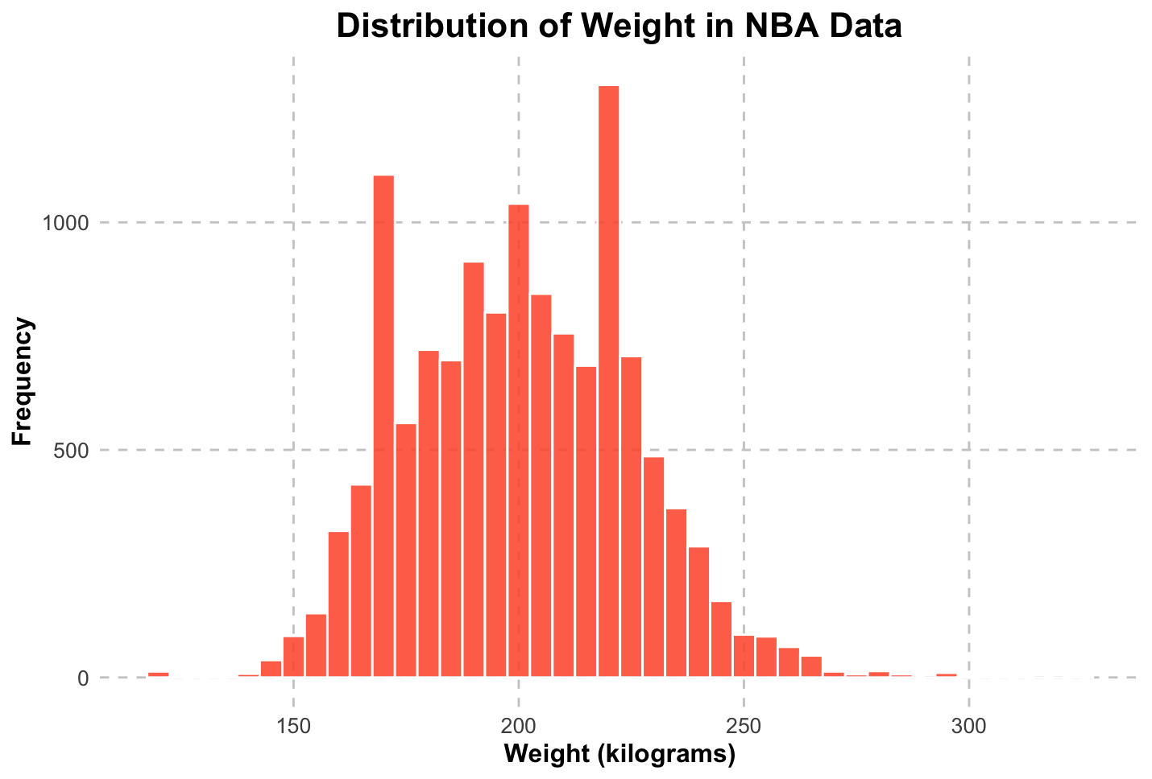

**Model & Analysis**

**Linear Regression Model**

Using the table to the left, we can see the regression model. Using this information, we can construct an equation. We can see that it is a positive relationship, predicting weight based on 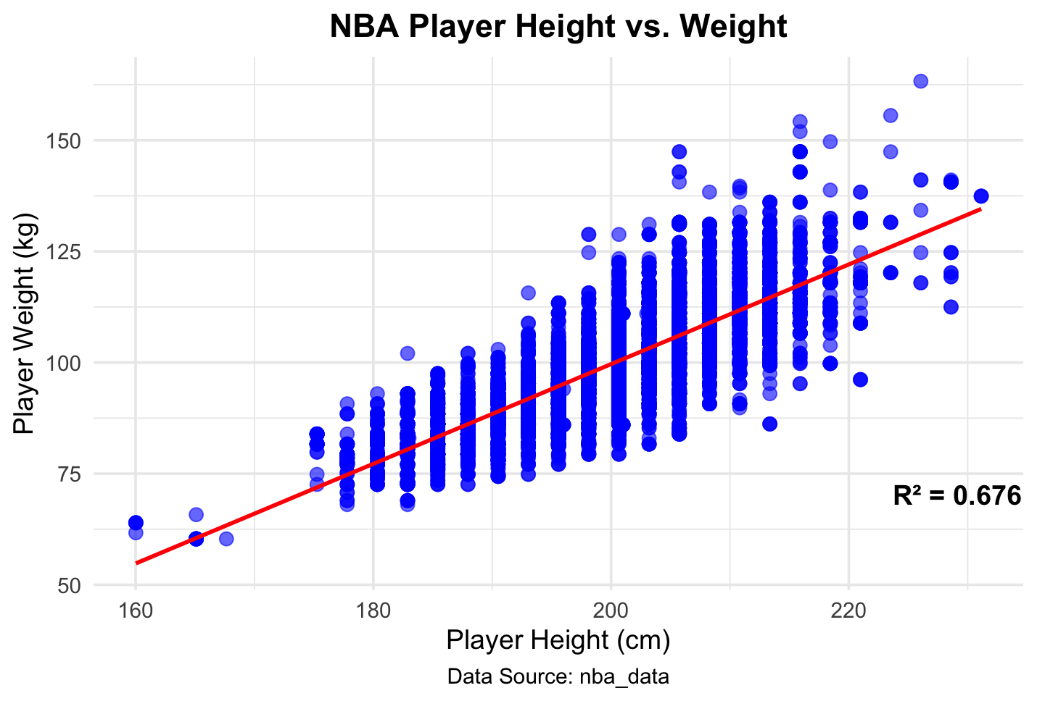height. The r-squared is 0.676, meaning that 67.6% of the variation in weight is explained by the variation in height.

**Regression Model Summary**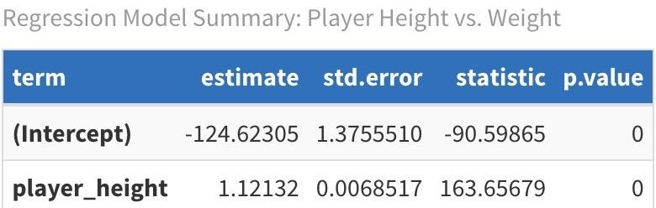

The equation for this is Weight = -124.62 + 1.12(Height). Two players that differ by one kg of weight, are expected to differ by 1.12 cm of height. The estimated value of weight at zero cm of height is -124.62. The standard error (std. error) of the model is about 1.37 for weight, meaning that the model can be roughly 1.37 units off given a certain value. The standard error for displacement is 0.006, meaning that the model can be roughly 0.006 units off given a certain value. This is great for our model because our model is quite accurate. The t-value for weight is -90.59 and the t-value for height is 163.65. This means that weight is -90.59 units away from zero in the opposite direction and height is 163.65 units away from zero. The P-value is zero for both weight and height, meaning that weight and height is unlikely to happen by random chance. This means that the lower the player’s height is, the lower the player’s height is. This makes sense because the shorter the player, the lower the weight.

**Assumptions Check**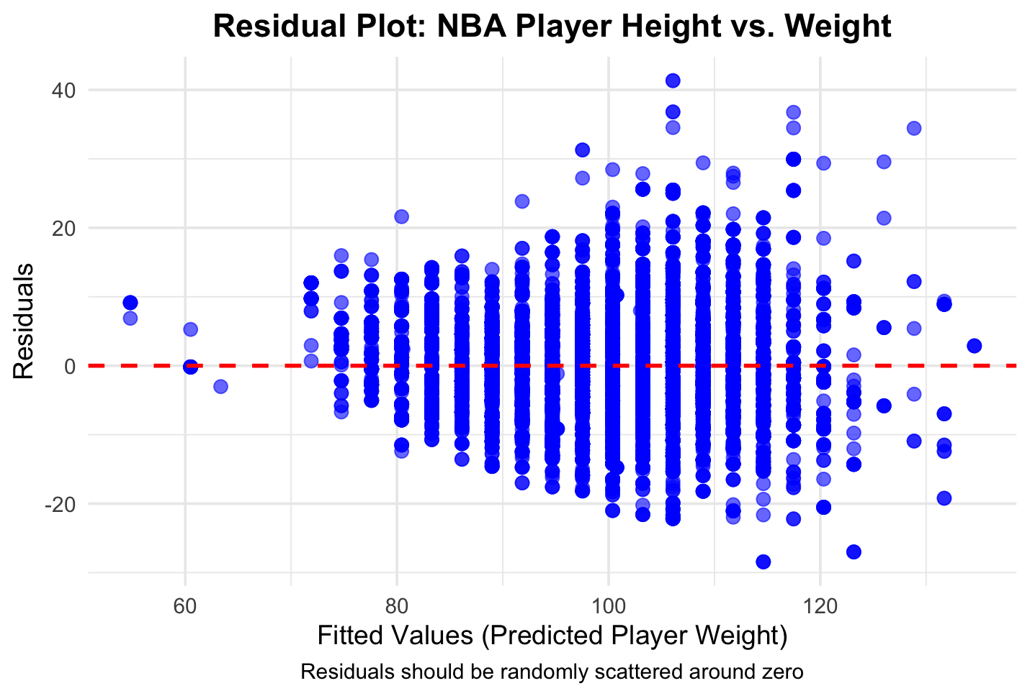

The assumptions needed to assess this model is linearity, equal spread, and normality. The p-values for all three are 0. We want a high p-value for these three assumptions, meaning that these assumptions do not hold.

**Transformations Model**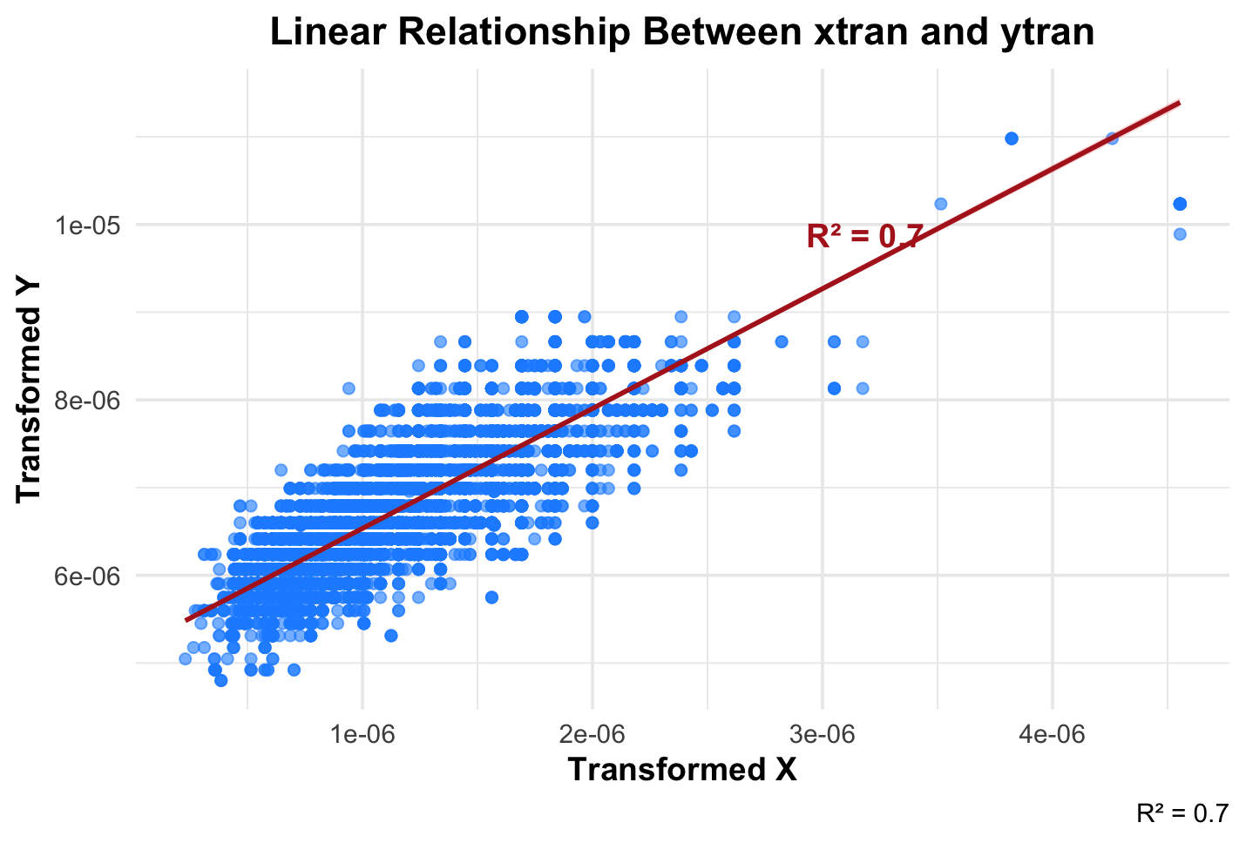

To the right, we can see the transformed version of our original model. The r-squared of this model is 0.7, meaning that 70% of the variation in weight is explained by the variation in height.

**Results & Conclusion**

**Model Evaluation**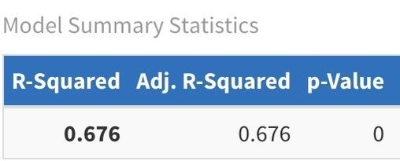

**This is the summary for the original model.** The r-squared for the original model is 0.676, while the r-squared for the transformed model is 0.7. This means that more variation is explained in the transformed model than the original model. The AIC for the original model is 86712.37, while the AIC for the transformed model is -342898. This means that the transformed model is better, because it’s a lower value. The adjusted r-squared for both models are equal to their r-squared.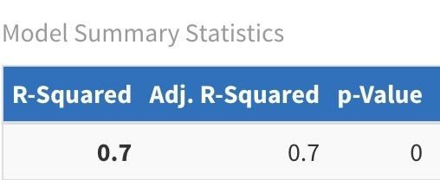

**This is the summary for the transformed model.**

**Conclusion**

If I were to choose one model out of the two, I would choose the transformed model because more variation is explained in the model and it has a lower AIC, meaning that it is a better model compared to the original model. There aren’t any weak or non-significant relationships when comparing height and weight of NBA players. This allows us to make better training regimens to allow players to reach their ideal weight.

**References**

* ChatGPT was used to make the graphics look better.
* A point was earned during class for answering a question.